ALGO 2010,
Hilton Hotel Liverpool, 6th – 10th September 2010

Expotel are pleased to offer a selection of hotels at discounted prices, a small sample of which are shown below. If you wish to book a hotel which is not listed, please name the hotel you require when requesting your booking or log on to www.expotel.com/algo2010

Hotel | Stars | Car  Parking | Approximate Distance & Journey Time to Venue | Single  Rate | Double / Twin Rate | Breakfast
Thistle Liverpool  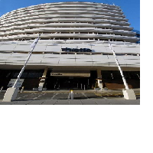 | 4 | OC | 0.3 Miles / 5 minutes walk | £85.00 | On request only | Full English
Novotel Liverpool  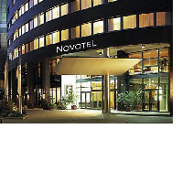 | 4 | NC | 0.3 Miles / 5 minutes walk | £69.00 | £79.00 | Full English
Jury’s Inn Liverpool  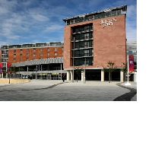 | 3 | NC | 0.2 Miles / 5 minutes walk | £69.00 | On request only | Full English
Britannia Liverpool  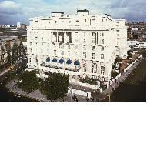 | 3 | OC | 0.5 Miles / 10 minutes walk | £75.00 | £95.00 | Full English
Radisson Blu Liverpool  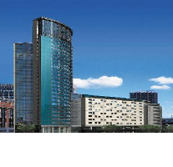 | 4 | OC | 0.7 Miles / 12 minutes walk | £95.00 | £105.00 | Full English

Car Parking Key:

OF = Onsite Free Parking OC = Onsite Chargeable Parking NC = Chargeable Parking Near to Hotel

PLEASE NOTE:

All prices shown are per room per night and include VAT at 17.5% with rates and room availability all subject to change. The booking can be cancelled up to 24 hours prior to arrival unless otherwise stated on your confirmation. Within this period full cancellation charges will apply.

Individual Bookings

Expotel will require details of a valid credit card in order to guarantee your booking with the hotel. No money will be charged at the point of booking, but you will be responsible for any non-arrival or late cancellation charges.

Group Bookings

- Different terms and cancellation deadlines will apply depending on the policy of the hotel.
- The full terms and conditions of the selected hotel will be notified to you at the time of booking.

All the information contained in this booking form is correct at the time of going to press. However, whilst every care has been taken in the completion of this form, errors or omissions are in no way the responsibility of Expotel.

If you require travel to this event please log on to: www.expotel.com/algo2010

PLEASE NOTE: The booking details requested on the attached form must be provided when booking online, by email, or by telephone.
A hotel reservation can be made by:
- Booking online at: www.expotel.com/algo2010

- Email to: exhibitions@expotel.com

- Telephoning: +44 (0) 844 793 7272

- Completing the attached form and faxing it to: +44 (0)161 443 1381

Event Code: algo2010
Booking Form

PLEASE COMPLETE THIS FORM CLEARLY AND IN BLOCK CAPITALS
Your Name:
Company:
Address:

Email:
Telephone:
Fax:

Please indicate your booking requirements:

Guest Name | Arriving On | Nights | Type of Room

Hotel 1st Choice:
Hotel 2nd Choice:
Name of Cardholder:
Card Number:
Start Date: |  |  | Expiry Date:
Card Type:  (Please tick where applicable) | Visa | Mastercard |  | Amex |  | Diners Club

PLEASE NOTE: The above credit card details will guarantee against non arrival and late cancellation charges only. Individual guests will be required to provide a credit / debit card when checking in to cover all extras during their stay.
I hereby authorise you to charge the above card as described above: The credit card will not be deducted unless you fail to arrive or cancel outside the policy.
Signed:
Date:

